**Product Shoppe**

Problem Statement

Universal Commodities need to maintain their products inventory for easier management by their staff members.

The staff member(s) are the administrators of the Shoppe.

Create an application using Angular 2 to achieve below mentioned functionalities.

Software Required

* Node JS (Latest version)
* Node Packages – Angular CLI
* Notepad ++ or Any IDE visual studio code

Assumption:

The staff members being Administrators are already validated to Login to the System.

As the application loads following page is displayed, Refer below screen shot for same:

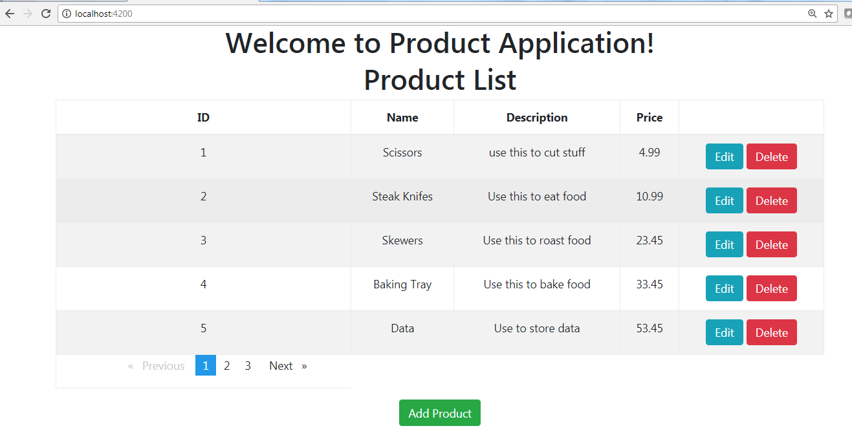

As seen there are a list of products displayed with edit / delete for every product.

Note:

1. There are many products, thus displayed with **Pagination**.
2. These products must be read from ‘**json**’ file. The data is populated by using **Observables and Reactive extensions.**
3. There is also an option **to Add Product**

When the staff would want to edit the Product by clicking on **Edit button** then the corresponding data for the product should be displayed. The user can then modify details and clicking on **Submit** would reflect the changes in the product list. In the next screen shot the price of product (Scissors) is updated.

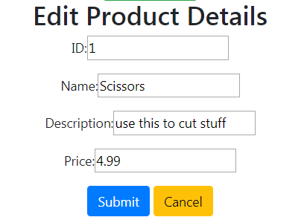 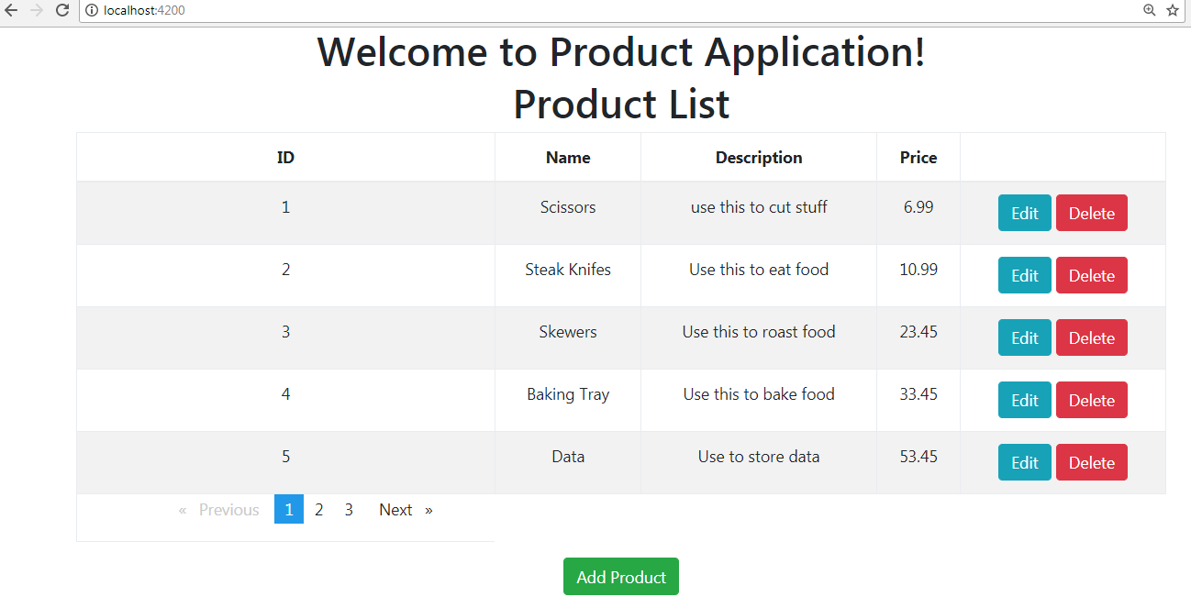

Similary if the staff would want to delete a Product then by clicking on the **Delete button** the corresponding product should be deleted from the list.

Refer below screen shot where the 5th Product is deleted from the list.

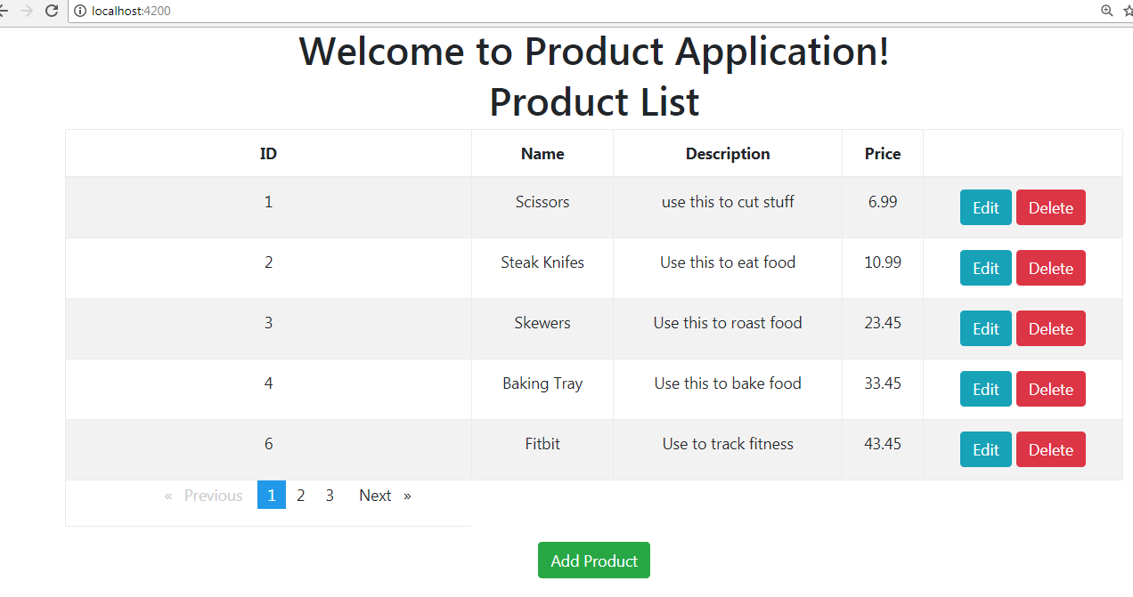

Moreover if the staff wants to add a product by clicking on **Add Product** button, then following screen should be displayed.

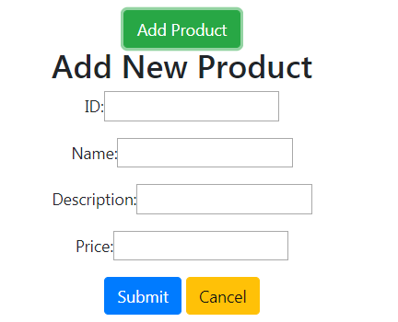

The user can add Product details, and the product details would be reflected in the list. Refer below screen shot with *‘Pokémon’* added as a Product.

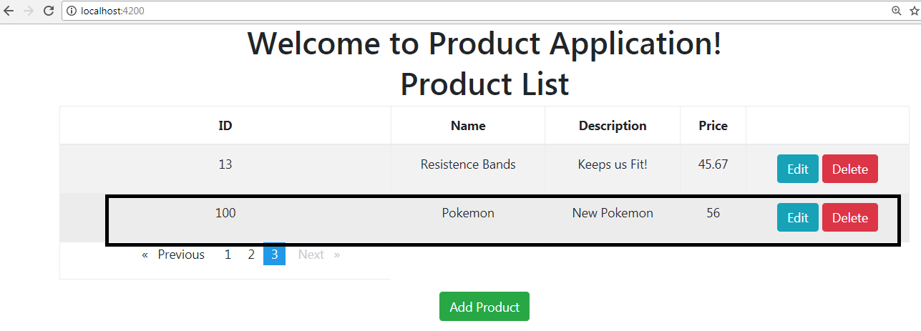

Note:

1. The list of Products is maintained as JSON.
2. Staff members could delete all products as well. So create Button Delete All that will all Products
3. Validation of Form

* All Field are required
* ID should be max 4digits
* Name should be start with Capital

**Evaluation Criteria (out of 50):**

This mini project will be done in groups of three to five. Each group will identify a Team Lead who will decide which team member will code for which functionality. This project shall be evaluated at the end of spring module.

**Evaluation Criteria (out of 50):**

|  |  |
| --- | --- |
| Look for all the screens | **10** |
| Client-side validation of inputs | **10** |
| Code Documentation and using coding standards | **03** |
| Overall Business logic. This includes: | **17** |
| Good amount of JSON & Service Use | **10** |